Relational and logical operators.
1)Write a query that will give you all names oders for more than 1000.

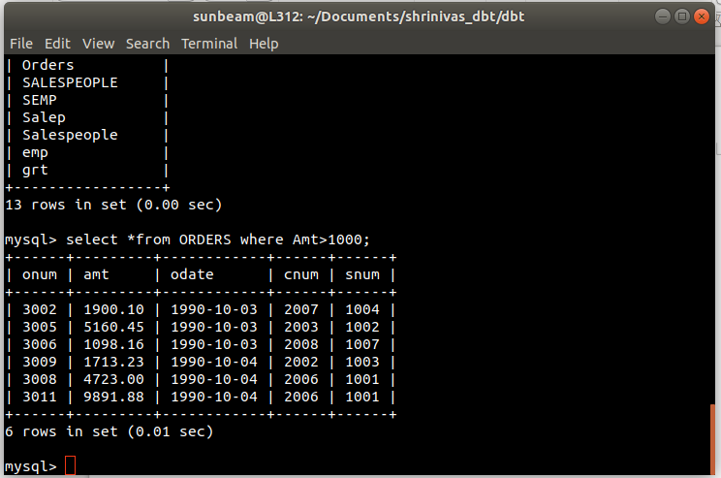

2)Write a query that will give you the names and cities of all salespeople in london with a commision avove .10.
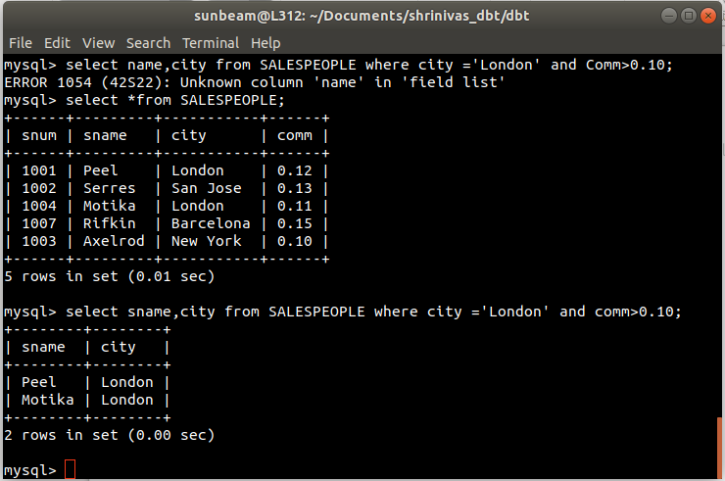
3) Write a query on the customers table whose output will exclude all customers with a rating <=100,unless they are located in Rome.
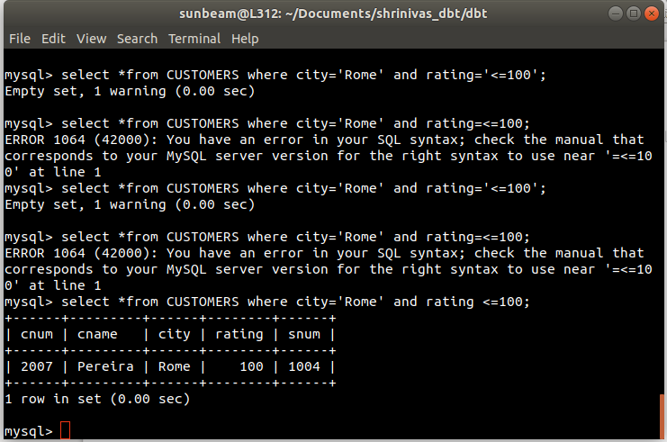

4) What will be the output from the following query?
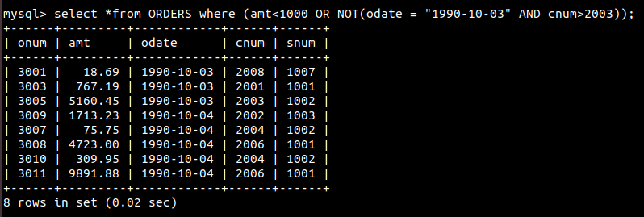

5)What will be the output from the following query?

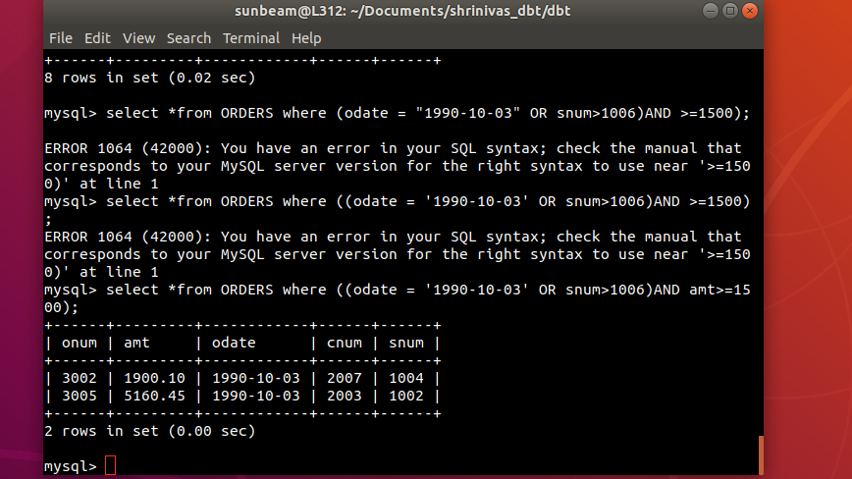

6)What is a simpler way to write this query?

